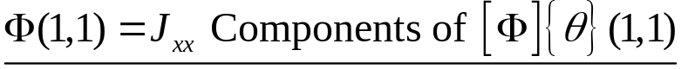
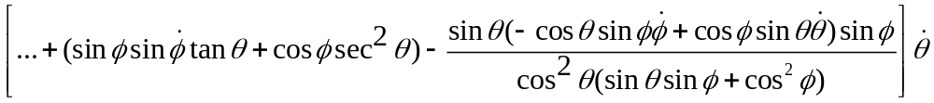
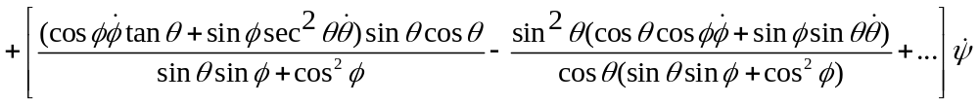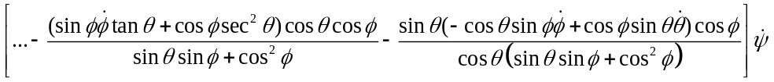
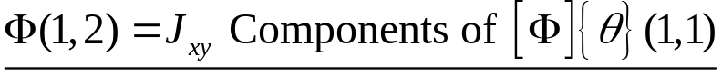
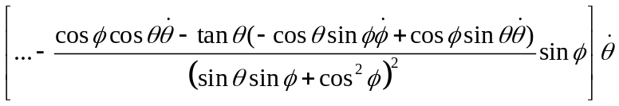
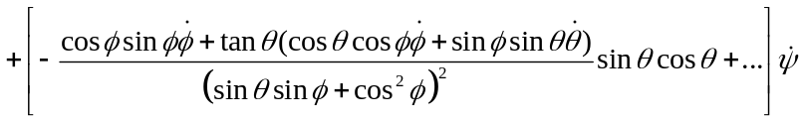
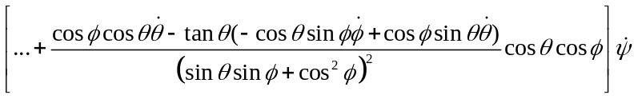
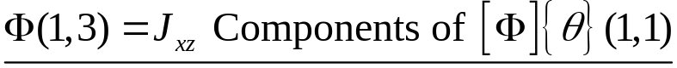
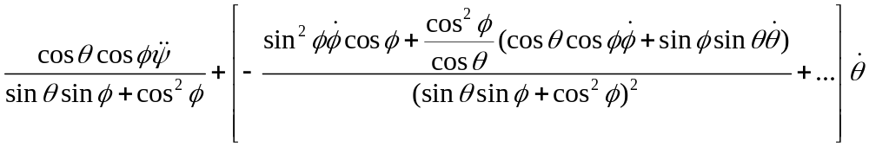
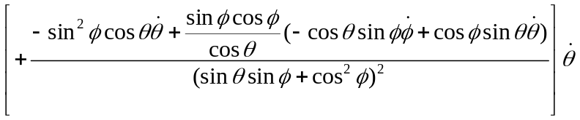
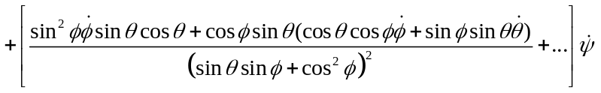
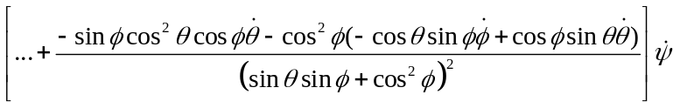
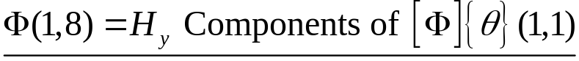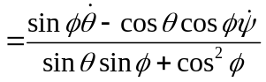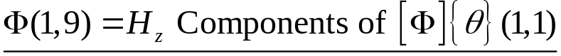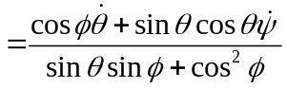
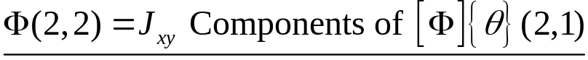
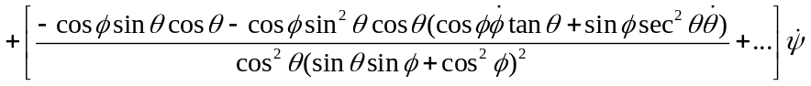
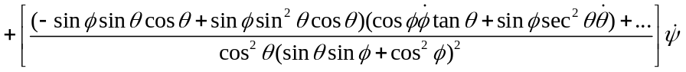
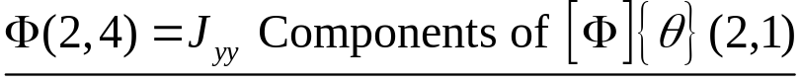
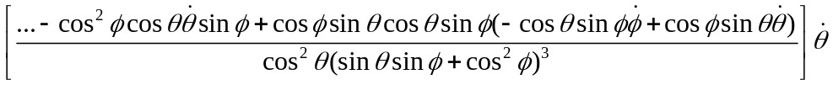
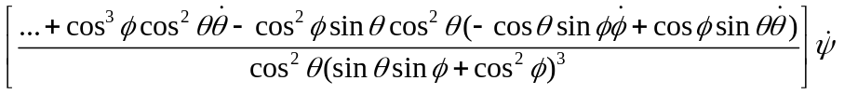
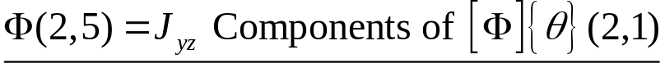
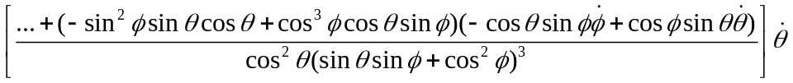
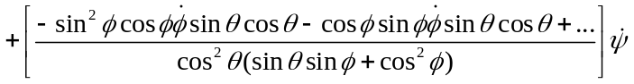
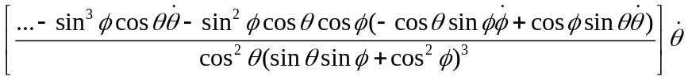
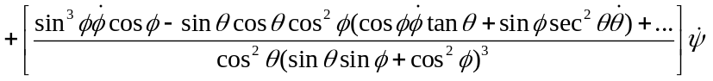
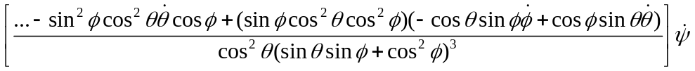
EMBED Equation.DSMT4 